“R” Occupancy Electrical Requirements:
Definitions:
Dwelling Unit: A single unit providing complete, independent living facilities for one or more persons, including permanent provisions for living, sleeping, eating, cooking and sanitation.
Sleeping Unit: A single unit that provides rooms or spaces for one or more persons, includes permanent provisions for sleeping and can include provisions for living, eating and either sanitation or kitchen facilities but not both.
(Sections referenced from the 2017, 2020, and 2023 NEC)
Note: RED text is new and only applies to the 2023 NEC
Article 210.8 GFCI Protection:
- Dwelling Units (Applies only to 120v / 15a and 20a circuits)
  - Bathrooms
  - Garages (Attached and unattached), spaces below grade not intended as habitable rooms and limited to storage areas, work areas, and areas of similar use
  - Outdoors
  - Crawl Spaces – at or below grade level
  - Unfinished portions or areas of the basement not intended as habitable rooms
  - Kitchens – where the receptacles are installed to serve the countertop surfaces
  - Areas with sinks and permanent provisions for food preparation, beverage preparation, or cooking. (NEW to 2023 NEC)
  - Sinks – Where receptacles are installed within 6 ft. from the top inside edges of the bowl of the sink.
  - Boathouses
  - Bathtubs or shower stalls –where receptacles are installed within 6 ft. of the shower / bathtub
  - Laundry areas
  - Indoor damp and we locations
- Other than Dwelling Units (All 1-phase recepts rated 150v or less, 50 amp or less)
  - Bathrooms
  - Kitchens
  - Areas with sinks and permanent provisions for food preparation, beverage preparation, or cooking. (NEW to 2023 NEC)
  - Buffet serving areas with permanent provisions for food serving, beverage serving, or cooking. (NEW to 2023 NEC)
  - Rooftops
  - Outdoors
  - Sinks – Where receptacles are installed within 6 ft. from the top inside edges of the bowl of the sink. (The 2023 added “Fixed or Stationary appliances”)
  - Indoor wet locations
  - Locker rooms with associated showering facilities
  - Garages (Attached and unattached), service bays, and similar areas other than vehicle exhibition halls and showrooms
  - Crawl spaces – at or below grade level
  - Unfinished portions or areas of the basement not intended as habitable rooms
  - Aquariums, bait wells, and similar open aquatic vessels or containers, such as tanks or bowls, where receptacles are installed 6 feet from the top inside edge or rim or from the conductive support framing of the vessel or container.
  - Laundry areas
  - Bathtubs and shower stalls where the receptacles are installed within 6 foot of the outside edge of the bathtub or shower stall
- Specific appliances (120v and 240v circuits up to 60amp)
  - Automotive vacuum machines
  - Drinking water coolers and bottle fill stations
  - High-pressure spray washing machines
  - Tire inflation machines
  - Sump pumps
  - Vending machines
  - Dishwashers
  - Electric ranges
  - Wall-mounted ovens
  - Counter-mounted cooking units
  - Clothes dryers
  - Microwave ovens
- Crawl space lighting outlets

Article 210.11 Branch Circuits Required
- Dwelling Units:
  - Small appliance branch circuits – (2) or more 20amp small appliance branch per 210.52(B).
  - Laundry branch circuits – Min. (1) 20amp branch circuit required. No other outlets are allowed on this circuit. (Note: This could be a dedicated circuit for the washer)
  - Bathroom branch circuits – Min. (1) 20amp branch circuit shall supply the bathroom(s) outlets. No other outlets are allowed on this circuit. (Note the bathroom receptacles can be combined on the same circuit)
  - Garage branch circuits – Min. (1) 20amp branch circuit required. No other outlets are allowed on this circuit.
Note: A branch circuit does not mean a dedicated receptacle. Multiple receptacles are allowed on a branch circuit. Those receptacles / circuit must be within the space they serve. Small appliance and laundry branch circuits must be figured no less than 1,500 watts (Article 220.52(A) & 220.52(B))

Article 210.12 AFCI Protection (Applies only to 120v / 15a and 20a circuits)
- Dwelling units
  - Kitchens
  - Family rooms
  - Dining rooms
  - Living rooms
  - Parlors
  - Libraries
  - Dens
  - Bedrooms
  - Sunrooms
  - Recreation rooms
  - Closets
  - Hallways
  - Laundry areas
  - Similar rooms or spaces as listed above
- Dormitory Units
  - Bedrooms
  - Living rooms
  - Hallways
  - Closets
  - Bathrooms
  - Similar rooms or spaces as listed above
- Guest rooms and guest suites
  - All outlets and devices installed in guest rooms / suites of hotels and motels

Article 210.17 Guest Rooms and Guest Suites
- Guest rooms / suites that are provided with permanent provisions for cooking shall have branch circuits installed shall meet the rules for dwelling units.
  - Hotels
  - Motels
  - Assisted Living Facilities
Article 210.25 Branch Circuits in Buildings with More Than One Occupancy
- Branch circuits in each dwelling unit shall supply only loads within that dwelling unit or loads associated only with that dwelling unit.
- Branch circuits installed for the purpose of lighting, central alarm, signal, communications, or other purposes for public or common area of a two family dwelling, a multi-family dwelling, or a multi-occupancy building shall not be supplied from equipment that supplies an individual dwelling unit or tenant space.

Article 210.52 Dwelling Unit Receptacle Outlets (Applies only to 120v /15a and 20a circuits)
- In every kitchen, family room, dining room, living room, parlor, library, den, sunroom, bedroom, recreation room, or similar room or area of dwelling units, receptacle outlets shall be installed in accordance with general provisions specified in 210.52(A)(1) through (A)(4).
- Spacing: Receptacles shall be installed such that no point measured horizontally along the floor line of any wall space is more than 6’ from a receptacle outlet.
- Wall Space:
  - Any space 2’ or more in width (including space measured around corners) and unbroken along the floor line by doorways and similar openings, fireplaces, and fixed cabinets that do not have countertops or similar work surfaces.
  - The space occupied by fixed panels in walls, excluding sliding panels.
  - The space afforded by fixed room dividers, such as free-standing bar-type counters or railings.
- Floor Receptacles: Receptacle outlets in or on floors shall not be counted as part of the required number of receptacle outlets unless located within 18” of the wall.
- Countertop and Similar Work Surface Outlets: Receptacles installed for countertop and similar work surfaces as specified in 210.52(C)(1) thru (C)(3) shall not be considered as the receptacle outlets required by 210. 52(A).
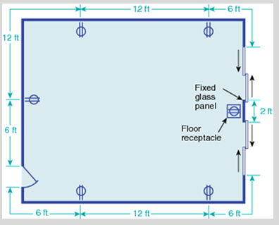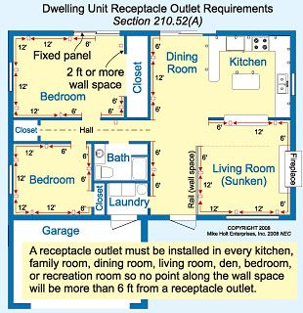
Article 210.52 Dwelling Unit Receptacle Outlets (Continued)
- Small Appliances:
- Receptacle Outlets Served: In the kitchen, pantry, breakfast room, dining room, or similar area of a dwelling unit, the two or more 15- or 20 amp small appliance branch circuits required by 210.11(C)(1) shall serve all wall and floor receptacle outlets covered by 210.52(A), all countertop outlets covered by 210.52(C), and receptacle outlets for refrigeration equipment.
  - Exception 1: In addition to the required receptacles specified by 210.52, switched receptacles supplied from a general-purpose branch circuit as defined in 210.70(A)(1), Exception 1, shall be permitted.
  - Exception 2: In addition to the required receptacles specified by 210.52, a receptacle outlet to serve a specific appliance shall be permitted to by supplied from an individual branch circuit rated 15amp or greater.
- No Other Outlets: The two or more small-appliance branch circuits specified in 210.52(B)(1) shall have no other outlets. (Note: These do not have to be dedicated receptacles. Multiple receptacles can be used for small-appliance branch circuits)
  - Exception 1: A receptacle installed solely for the electrical supply to and support of an electric clock in any of the rooms specified in 210.52(B)(1).
  - Exception 2: Receptacles installed to provide power for supplemental equipment and lighting on gas-fired ranges, ovens, or counter-mounted cooking units.
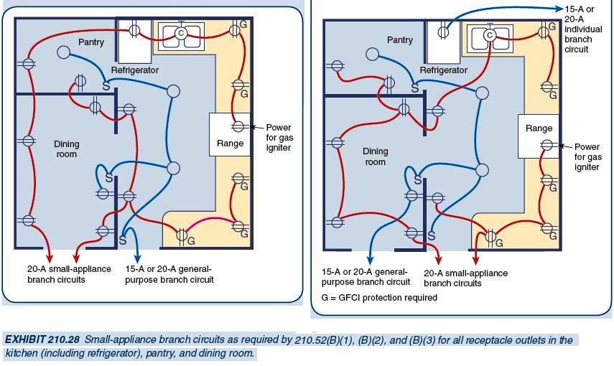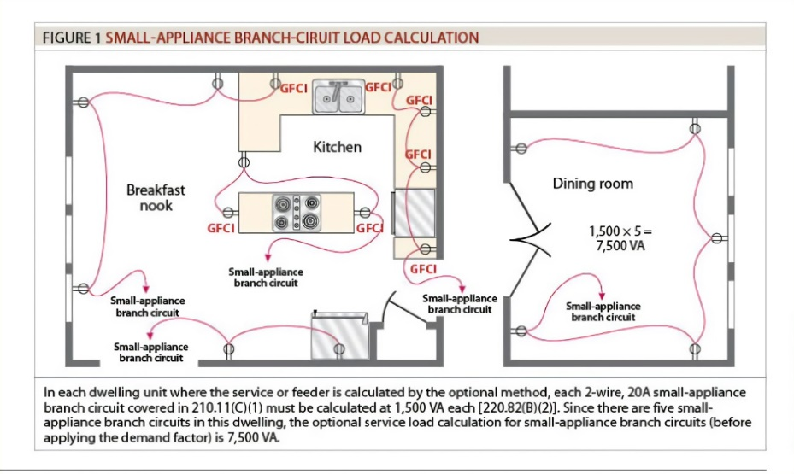
Article 210.52 Dwelling Unit Receptacle Outlets (Continued)
- Countertops and Work Surfaced: In kitchens, pantries, breakfast rooms, dining rooms, and similar areas of dwelling units, receptacle outlets for countertop shall be installed in accordance with 210.52(C)(1) through (C)(5).
- Wall Countertop and Work Surface: A receptacle outlet shall be installed at each wall countertop and work surface that is 12” or wider. Receptacle outlets shall be installed so that no point along the wall line is more than 24” measured horizontally from a receptacle outlet in that space
  - Exception: Receptacle outlets shall not be required on a wall directly behind a range, counter-mounted cooking unit, or sink (See examples at bottom of page)
- Island Countertop Spaces: At least on receptacle shall be installed at each island countertop space with a long dimension of 24” or greater and a short dimension of 12” or greater.
  - (NEW to 2023) Island and Peninsular Countertops and Work Surfaces: Receptacle outlets, if installed to serve an island or peninsular countertop or work surface, shall be installed in accordance with 210.52(C)(3). If a receptacle outlet is not provided to serve an island or peninsular countertop or work surface, provisions shall be provided at the island or peninsular for future addition of a receptacle outlet to serve the island or peninsular countertop or work surface.
- Peninsular Countertop Spaces: At least one receptacle outlet shall be installed at each peninsular countertop long dimension space with a long dimension of 24” or greater and a short dimension of 12” or greater. A peninsular countertop is measured from the connected perpendicular wall.
- Separate Spaces: Countertop spaces separated by range-tops, refrigerators, or sinks shall be considered as separate countertop spaces in applying the requirements of 210.52(C)(1). If a range, counter-mounted cooking unit, or sink is installed in an island or peninsular countertop and the depth of the countertop behind the range, counter-mounted cooking equipment, or sink is less than 12”, the range, counter-mounted cooking unit, or sink shall be considered to divide the countertop space into two separate countertop spaces. Each separate countertop space shall comply with the applicable requirements in 210.52(C).
- Receptacle Outlet Location: Receptacle outlets shall be located on or above, but not more than 20” above, the countertop or work surface. Receptacle outlet assemblies listed for use in countertops or work surfaces shall be permitted to be installed in countertop / work surfaces. Receptacle outlets not readily accessible by appliances fastened in place, appliance garages, sinks, or range tops as covered in 210.52(C)(1), Exception, or appliances occupying dedicated space shall not be considered as these required outlets required. In a work surface using receptacle outlet assemblies listed for use in a work surface or listed for use in countertops.
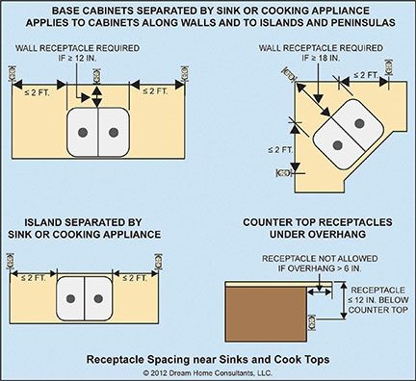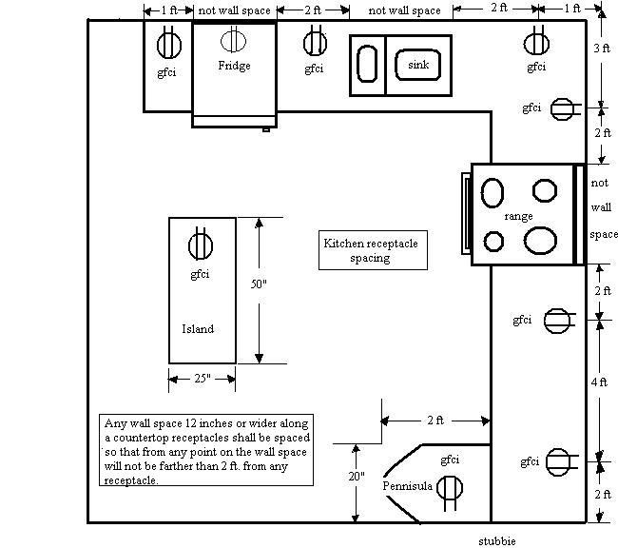
Article 210.52 Dwelling Unit Receptacle Outlets (Continued)
- Bathrooms: At least (1) receptacle outlet shall be installed in bathrooms within 3’ of the outside edge of each basin. The receptacle outlet shall be located on a wall or partition that is adjacent to the basin or basin countertop, located on the countertop, or installed on the side or face of the basin cabinet. In no case shall the receptacle be located more than 12” below the top of the basin or basin countertop. Receptacle outlet assemblies listed for use on countertops shall be permitted to be installed in the countertop.
- Outdoor Outlets: Outdoor receptacle outlets shall be installed in accordance with 210.52(E)(1) through (E)(3).
- One-Family and Two-Family Dwellings: For a one-family dwelling and each unit of a two-family dwelling that is at grade level, at least one receptacle outlet readily accessible from grade and not more than 6’-6” above grade level shall be installed at front and back of the dwelling.
- Multi-Family Dwellings: For each dwelling unit of a multi-family dwelling where the dwelling unit is located at grade level and provided with individual exterior entrance / egress, at least (1) receptacle outlet readily accessible from grade level and not more than 6’-6” above grade shall be installed.
- Balconies, Decks, and Porches: Balconies, decks, and porches that are attached to the dwelling unit and are accessible from inside the dwelling unit shall have at least (1) receptacle outlet accessible from the balcony, deck, or porch. The receptacle outlet shall not be located more than 6’-6” above the balcony, deck, or porch walking surface.
- Laundry Areas: In dwelling units, at least (1) receptacle outlet shall be installed in areas designated for the installation of laundry equipment.
  - Exception 1: A receptacle for laundry equipment shall not be required in a dwelling unit of a multi-family building where laundry facilities are provided on the premises for use by all building’s occupants.
  - Exception 2: A receptacle for laundry equipment shall not be required in other than one-family dwellings where laundry facilities are not to be installed or permitted.
- Basements, Garages, and Accessory Buildings: For one- and two-family dwellings, at least (1) receptacle outlet shall be installed in the areas specified in 210.52(G)(1) through (3). These receptacles shall be in addition to receptacles required for specific equipment.
- Garages: In each attached garage and in each detached garage with electrical power, at least (1) receptacle outlet shall be installed in each vehicle bay and not more than 5’-6” above the floor.
- Accessory Buildings: In each accessory building with electrical power.
- Basements: In each separate unfinished portion of a basement.
- Hallways: In dwelling units, hallways 10’ or more in length shall have at least one receptacle outlet.
  - The hallway length shall be considered the length along the centerline of the hallway without passing through a doorway.
- Foyers: Foyers that are not part of a hallway in accordance with 210.52(H) and that have an area that is greater than 60 sq. ft. shall have a receptacle(s) located in each wall space 3’ or more in width. Doorways, door-side windows that extend to the floor, and similar openings shall not be considered wall space.

Article 210.60 Guest Rooms, Guest Suites, Dormitories, and Similar Occupancies
- General: Guest rooms or guest suites in hotels, motels, sleeping rooms in dormitories, and similar occupancies shall have receptacle outlets installed in accordance with 210.52(A) through (D). Guest rooms or guest suites provided with permanent provisions for cooking shall have receptacle outlets installed in accordance with all the applicable rules in 210.52.
- Receptacle Placement: In applying the provisions of 210.52(A), the total number of receptacle outlets shall not be less than the minimum number that would comply with the provisions of that section. These receptacle outlets shall be permitted to be located conveniently for permanent furniture layout. At least two receptacle outlets shall be readily accessible. Where receptacles are installed behind the bed, the receptacle shall be located to prevent the bed from contacting any attachment plug that may be installed or the receptacle shall be provided with a suitable guard.

Article 210.70 Lighting Outlets Required: Lighting outlets shall be installed where specified in 210.70(A), (B), and (C).
- Dwelling Units: In dwelling units, lighting outlets shall be installed in accordance with 210.70(A)(1), (A)(2), and (A)(3).
- Habitable Rooms: At least one wall switch-controlled lighting outlet shall be installed in every habitable room, kitchen, and bathroom.
  - Exception 1: In other than kitchens and bathrooms, one or more receptacles controlled by a wall switch shall be permitted in lieu of lighting outlets.
  - Exception 2: Lighting outlets shall be permitted to be controlled by occupancy sensors that are (1) in addition to wall switches or (2) located at a customary wall switch location and equipped with a manual override that will allow the sensor to function as a wall switch.
- Additional Locations: Additional lighting outlets shall be installed in accordance with the following:
  - At least one wall switch-controlled lighting outlet shall be installed in hallways, stairways, attached garages, and detached garages with electrical power.
  - For dwelling units, attached garages, and detached garages with electrical power, at least one wall switch-controlled lighting outlet shall be installed to provide illumination on the exterior side of outdoor entrances or exits with grade-level access. A vehicle door in a garage shall not be considered as an outdoor entrance or exit.
  - Where one or more lighting outlet(s) are installed for interior stairways, there shall be a wall switch at each floor level, and landing level that includes an entryway, to control the lighting outlet(s) where the stairway between floor levels has six risers or more.
Exception to (A)(2)(a), (A)(2)(b), and (A)(2)(c): In hallways, in stairways, and at outdoor entrances, remote, central, or automatic control of lighting shall be permitted.
  - Lighting outlets controlled in accordance with 210.70(A)(2)(c) shall not be controlled by use of dimmer switches unless they provide the full range of dimming control at each location.
Article 210.70 Lighting Outlets Required (Continued)
- Storage or Equipment Spaces: For attic, underfloor spaces, utility rooms, and basements, at least (1) lighting outlet containing a switch or controlled by a wall switch shall be installed where these spaces are used for storage or contain equipment requiring servicing. At least one point of control shall be at the usual point of entry to these spaces. The lighting outlet shall be provided at or near the equipment requiring servicing.
- Guest Rooms or Guest Suites: In hotels, motels, or similar occupancies, guest rooms or guest suites shall have at least (1) wall switch-controlled lighting outlet installed in every habitable room and bathroom.
  - Exception 1: In other than kitchens and bathrooms, one or more receptacles controlled by a wall switch shall be permitted in lieu of lighting outlets.
  - Exception 2: Lighting outlets shall be permitted to be controlled by occupancy sensors that are (1) in addition to wall switches or (2) located at a customary wall switch location and equipped with a manual override that will allow the sensor to function as a wall switch.
- All Occupancies: For attics and underfloor spaces, utility rooms, and basements, at least (1) lighting outlet containing a switch or controlled by a wall switch shall be installed where these spaces are used for storage or contain equipment requiring servicing. At least one point of control shall be at the usual point of entry to these spaces. The lighting outlet shall be provided at or near the equipment requiring servicing.

Note:
- The 2020 NEC defines a Habitable Room as: A room in a building for living, sleeping, eating, or cooking, but not excluding bathrooms, toilet rooms, closets, hallways, storage or utility spaces, and similar areas.
- As per (A)(1) exception 1, in all spaces other than the kitchen and bathrooms, a wall switch can control one of the receptacles in the other spaces.
- For kitchens and bathrooms, if a dome light, can light, or light with a wired backer-box is not installed, then a wired box at the ceiling could be provided and installed on a single toggle switch.
- In closets and bathrooms, if a dome light, can light, vanity light, or light with a wired backer-box is provided, then that will be considered a lighting outlet since it has a switched wired box to control those fixtures.
Article 314.27 (2): Ceiling Outlets: At every outlet used exclusively for lighting, the box shall be designed or installed so that a luminaire or lamp holder may be attached. Boxes shall be required to support a luminaire weighing a minimum of 50lbs. A luminaire that weighs more than 50lbs shall be supported independently of the outlet box, unless the outlet box is listed for not less than the weight to be supported. The interior of the box shall be marked by the manufacturer to indicate the maximum weight the box shall be permitted to support.
      - Lighting outlets need to be able to support a min. of 50 lbs.
      - Article 314.27, Exception: Vertical boxes are allowed to support a light / luminaire a minimum of 6lbs.
Comment Note: As mentioned in item 4, a lighting outlet is a switched powered junction box. This can be a box for a ceiling fan, dome light, track lighting, vanity lights in the wall, etc. If we supply the fixture with the backing j-box, then the requirements are met, but it must be designed to support at least 50lbs. In bathrooms and kitchens, a switched lighting outlet is required. The switched, wired j-box can be either in the wall or ceiling. Our standard 2’x4’ LED lights do not have a backing box directly behind them, so these would not be considered as a lighting out. Other spaces, we can provide a switched outlet. In homes, these are commonly installed upside-down, as a courtesy from a design standpoint.

Article 406.12 Tamper –Resistant Receptacles: All 15amp and 20amp, 120v & 240v non-locking-type receptacles in the areas as specified in 406.12(1) through (7) shall be listed tamper-resistant receptacles.
- Dwelling units in all areas specified in 210.52 and 550.13
- Guest rooms and guest suites of hotels and motels
- Childcare facilities
- Preschools and elementary education facilities
- Business office, corridors, waiting rooms and the like in clinics, medical and dental offices and outpatient facilities
- Subset of assembly occupancies described in 518.2 to include places of waiting transportation, gymnasiums, skating rinks, dining and drinking facilities, places of worship, and auditoriums
- Dormitories
Exception to 1 through 7:
    - Receptacles located more than 5’-6” above the floor
    - Receptacles that are part of a luminaire or appliance
    - A single receptacle or a duplex receptacle for two appliances located within the dedicated space for each appliance that, in normal use, is not easily moved from one place to another and that is cord-and-plug-connected in accordance with 400.10(A)(6), (A)(7), or (A)(8)
    - Non-grounding receptacles used for replacements are permitted in 406.4(D)(2)(a)
Tamper-proof receptacle changes to the 2023 NEC
- Dwelling units, boathouses, mobile homes, and manufactured homes, including their attached and detached garages, accessory buildings, and common areas
- Guest rooms and guest suites of hotels and motels, and their common areas.
- Childcare facilities
- Preschools and education facilities
- Within clinics, medical and dental offices, and outpatient facilities, the following spaces:
  - Business offices accessible to the general public
  - Lobbies, and waiting spaces
  - Spaces of nursing homes and limited care facilities covered in 517.10(B)(2)
  - Places of awaiting transportation, gymnasiums, skating rinks, fitness centers, and auditoriums
- Dormitory units
- Assisted living facilities
- Residential care/assisted living facilities, social and substance abuse rehabilitation facilities, and group homes.
- Foster care facilities, nursing homes, and psychiatric hospitals
- Areas of agricultural buildings accessible to the general public and any common areas
Note: This requirement is for receptacles identified as 5-15, 5-20, 6-15, & 6-20

Exceptions:
- Receptacles located more than 5-1/2 feet above the floor.
- Receptacles that are part of a luminaire or appliance.
- Where the receptacle outlet is installed within the space occupied by or designated for each appliance that, in normal use, is not easily moved from one place to another and is cord-and-plug connected.
  - A singe receptacle that is not readily accessible and supplies one appliance.
  - A singe receptacle that is not readily accessible and supplies two appliances.
Nonground receptacles used for replacements as permitted in 406.4(D)(2)(a).

